Aina Paola D. Enriquez

2-ECE-B

**Programming Assignment Proof**

*Data Wrangling Using Pandas*

Problem 1

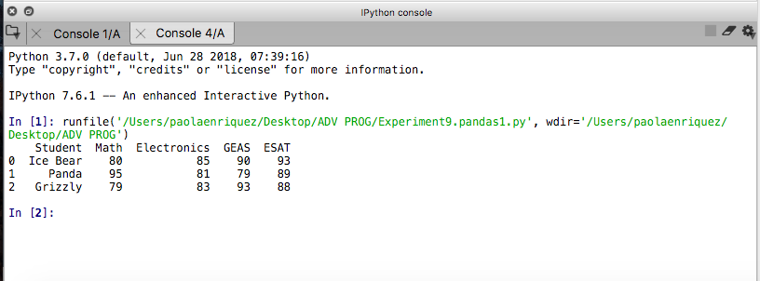

Figure 1.1

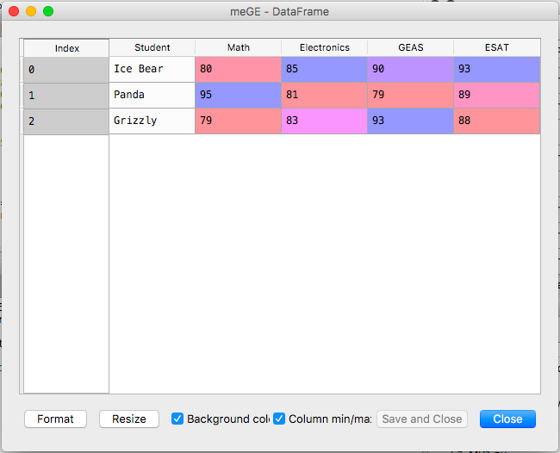

Figure 1.2

Problem 2

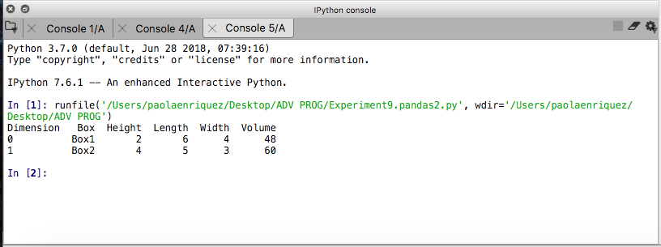

Figure 2.1

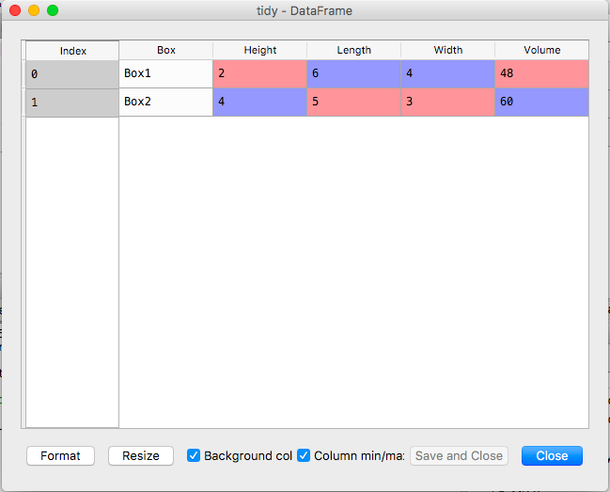

Figure 2.2